**Position Title**

Time Commitment: xx hours/month (or week)

Reports to/Works with:

Position Description:

Narrative about position – who this position reports to, general responsibilities, decisions made, etc.

Specific Duties:

* A
* List
* Goes
* Here

Preferred Skills:

* A
* List
* Goes
* Here

To Apply/Express Interest:

What should folks submit to apply or express their interest, and to whom should they send information? Is there a form, link, or other tool?

Inclusion Statement:

Narrative about DEI if relevant. Option to mention ‘preferred’ versus ‘required’ skills. Might mention selection process or provide encouragement to those who wouldn’t traditionally seek out a role like this.

Contact: [email and/or phone number for further info]

**Fundraising Committee Member**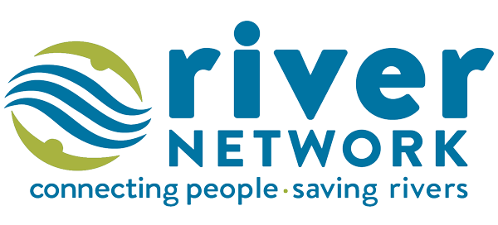

Time Commitment: 6 hours/month

Works with: Program Director, Board Chair, Fundraising Committee Members

Position Description:

Fundraising committee members are responsible for securing revenue for the organization in creative ways. The committee meets once per month to discuss upcoming opportunities, manage campaigns, and strategize on fundraising outreach.

Specific Duties:

* Attend monthly meetings (second Tuesdays @ 7 pm)
* Review provided materials ahead of meeting and participate in post-meeting action steps
* Contribute regularly to fundraising leads
* Help organize fundraising events

Preferred Skills:

* Event planning
* Written communication (solicitations, recognition/appreciation)
* Grant writing/management
* Familiarity with donor management software

To Express Interest:

Please send a brief statement of interest to info@organization.org with “Fundraising Committee Member” in the subject line. Statements should include skills and experiences relevant to the committee. Statements do not need to be formal, and shouldn’t be more than 1-2 paragraphs.

Inclusion Statement:

Organization invites people from all experience levels and backgrounds to join our board committees! We benefit from all contributions; formal or professional experience is not needed to participate. We recognize that gifts to our organization come in the form of time, treasure, and talent.

Contact: [email and/or phone number for further info]